Padding & Strides in CNN | CNN | Deep Learning



covering Padding and Strides in Convolutional Neural Networks (CNNs), drawing from the provided source:
1. Introduction to Padding and Strides
- This class continues the discussion on deep learning and CNNs, following a previous video on the convolution operation.
- It focuses on two additional operations crucial for CNNs: Padding and Strides.
2. Need for Padding
- Before discussing padding, it's essential to understand why it's needed.
- When a filter is convolved over an image, the resulting feature map is smaller than the original image.
  - For example, a 5x5 image convolved with a 3x3 filter results in a 3x3 feature map.
- Problem 1: Reduction in Resolution/Information Loss
  - If multiple convolutional layers are applied consecutively, the image size will continuously decrease.
  - This leads to a loss of information with each layer, which is generally undesirable.
- Problem 2: Underrepresentation of Border Pixels
  - Pixels at the borders (sides, top, bottom) of an image are part of fewer convolution operations compared to the central pixels.
  - For instance, a pixel in the top row might participate in only one convolution operation, while a central pixel could be part of three to four operations.
  - This means that when the feature map is generated, the central pixels have a greater "say" or importance, while the side pixels' influence is reduced.
  - If crucial information is located at the borders, it might not be effectively filtered out and represented in the feature map.
- Padding solves both these problems.
3. What is Padding?
- Padding involves adding rows and columns around the border of an image.
- Typically, these added pixels have a value of zero, which is why it's often referred to as zero-padding in literature.
- How it works (Example):
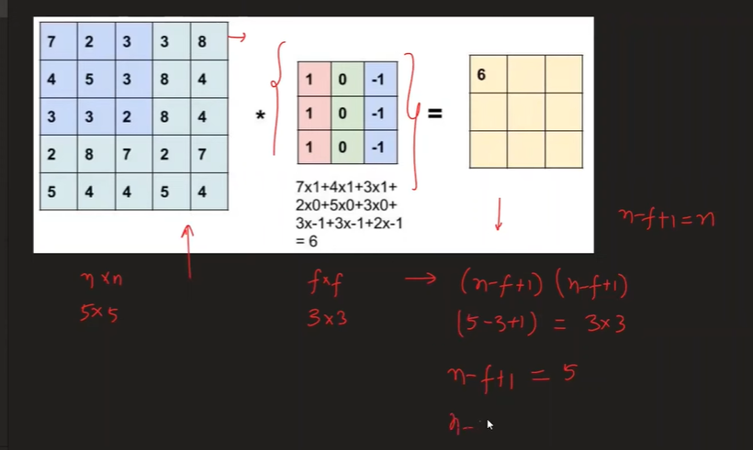
  - If you have a 5x5 image and add one column and one row on each side (top, bottom, left, right), the image becomes 7x7.
  - When a 3x3 filter is then convolved over this 7x7 padded image, the resulting feature map is 5x5, the same size as the original input image.
4. Formula for Feature Map Size with Padding

- Without Padding: For an N x N image and an F x F filter, the feature map size is (N - F + 1) x (N - F + 1).
- With Padding: If 'P' represents the amount of padding (e.g., P=1 for adding one pixel on each side), the formula becomes (N + 2P - F + 1) x (N + 2P - F + 1).
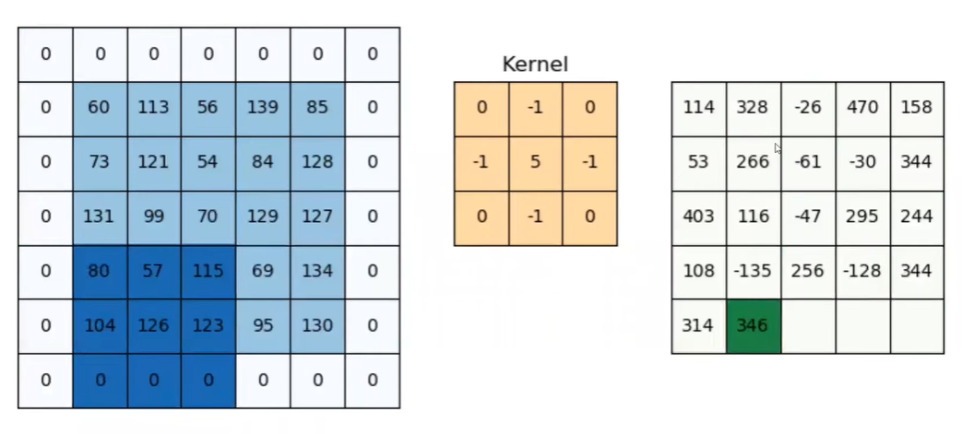
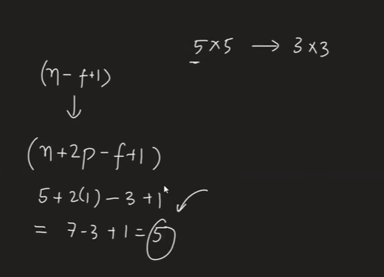
  - Example: For a 5x5 image (N=5) with P=1 padding and a 3x3 filter (F=3): (5 + 2*1 - 3 + 1) = (5 + 2 - 3 + 1) = 5. So, the output is a 5x5 feature map.
5. Padding Options in Keras
- Keras offers two primary padding options:
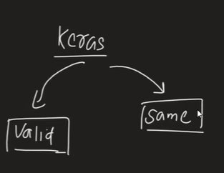
  - 'valid': No padding is applied. Convolution happens normally, and the output feature map will be smaller than the input.
  - 'same': Keras automatically calculates and applies the necessary amount of padding to ensure that the output feature map has the same size as the input image.
- Keras Demo for Padding:
keras-padding-demo.ipynb
  - A model without padding (padding='valid') shows an input of 28x28 progressively reducing to 26x26, then 24x24, and finally 22x22 after three convolutional layers. This follows the (N - F + 1) formula.
  - The exact same model, but with padding='same', maintains the image size at 28x28 across all convolutional layers. This demonstrates how 'same' padding prevents information loss by preserving resolution.
6. What are Strides?

- The stride value defines how many pixels the filter shifts (or "steps") across the input image after each convolution operation.
- Default Stride (Stride = 1): In a standard convolution, the filter moves one pixel to the right, and once it reaches the end of a row, it moves one pixel down. This is a stride of 1x1.


- Custom Strides (e.g., Stride = 2):
  - If the stride is set to 2, the filter will move two pixels to the right after each operation.
  - When moving down to the next row, it will also jump two pixels down.
  - This "skipping" of pixels means the filter covers less of the image and takes larger steps.
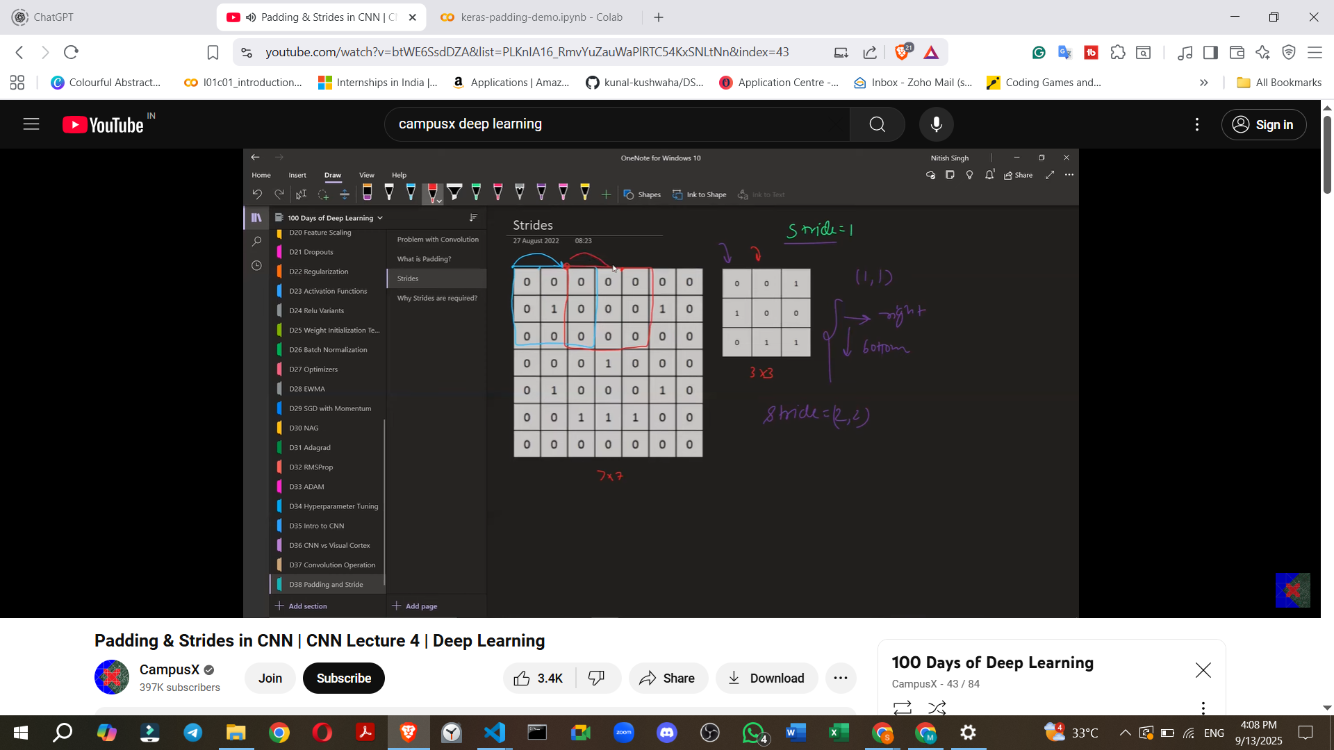
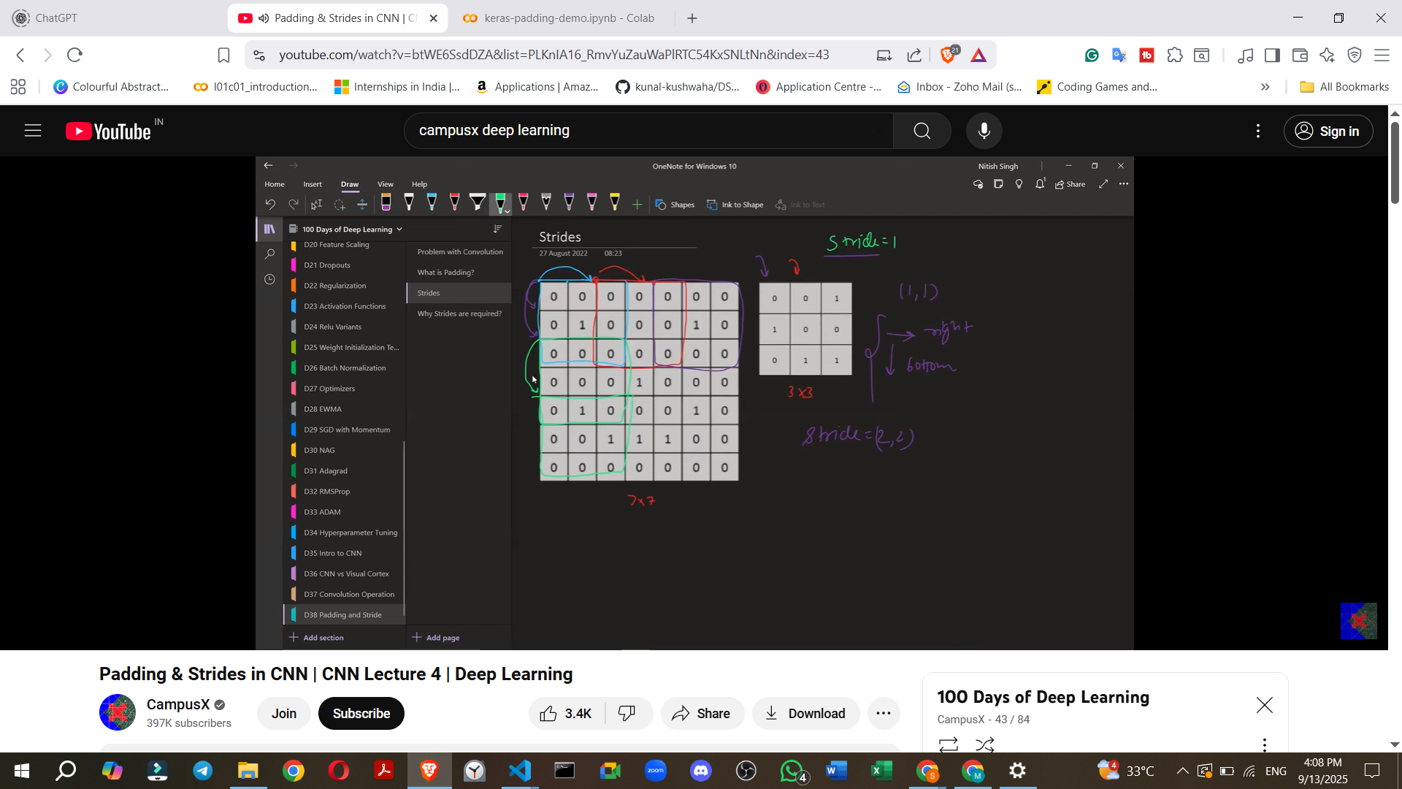
7. Effect of Strides on Feature Map Size
- Increasing the stride value decreases the size of the feature map.
- Formula for Feature Map Size with Strides (without Padding):
  - For an N x N image, an F x F filter, and a stride 'S', the feature map size is ((N - F) / S + 1) x ((N - F) / S + 1).
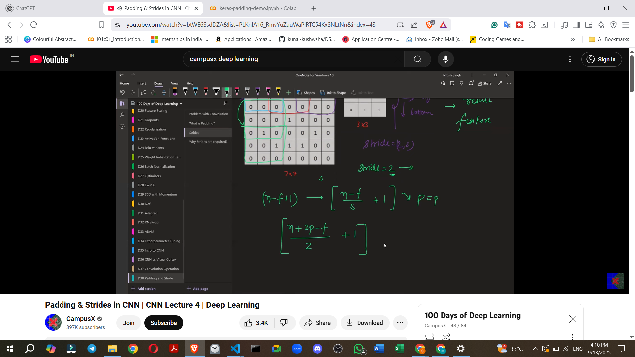
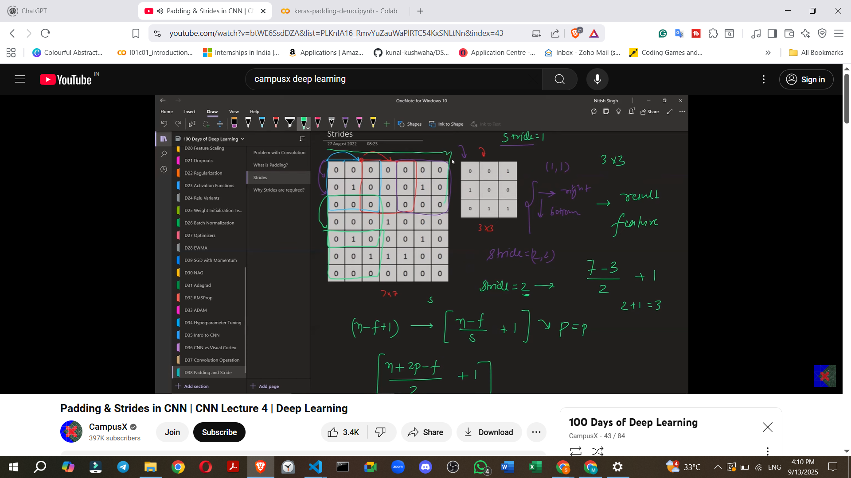
- Formula for Feature Map Size with Strides and Padding:
  - If padding 'P' is also considered, the formula becomes ((N + 2P - F) / S + 1) x ((N + 2P - F) / S + 1).
  - Example: For a 7x7 image (N=7), a 3x3 filter (F=3), and a stride of 2 (S=2) with no padding (P=0): ((7 + 2*0 - 3) / 2 + 1) = (4 / 2 + 1) = (2 + 1) = 3. The output feature map would be 3x3.
  - If P=1 padding was applied: ((7 + 2*1 - 3) / 2 + 1) = (6 / 2 + 1) = (3 + 1) = 4. The output feature map would be 4x4.
  - 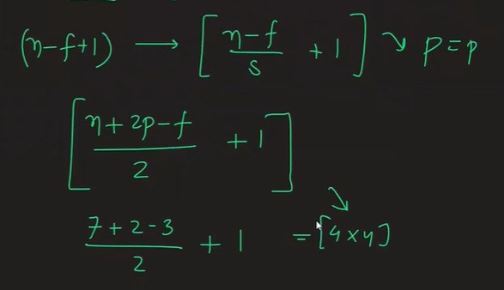
8. Special Case: Decimal Values with Strides
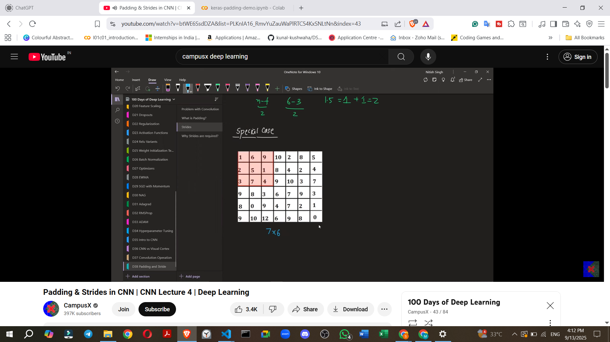
- When calculating the feature map size using the stride formula, if (N - F) / S (or (N + 2P - F) / S) results in a decimal value, a floor operation is applied.
- This means the result is rounded down to the nearest whole number.
- Reason: A decimal value indicates that there are not enough pixels remaining for the filter to perform a full convolution operation with the given stride, so that last incomplete operation is simply not performed.
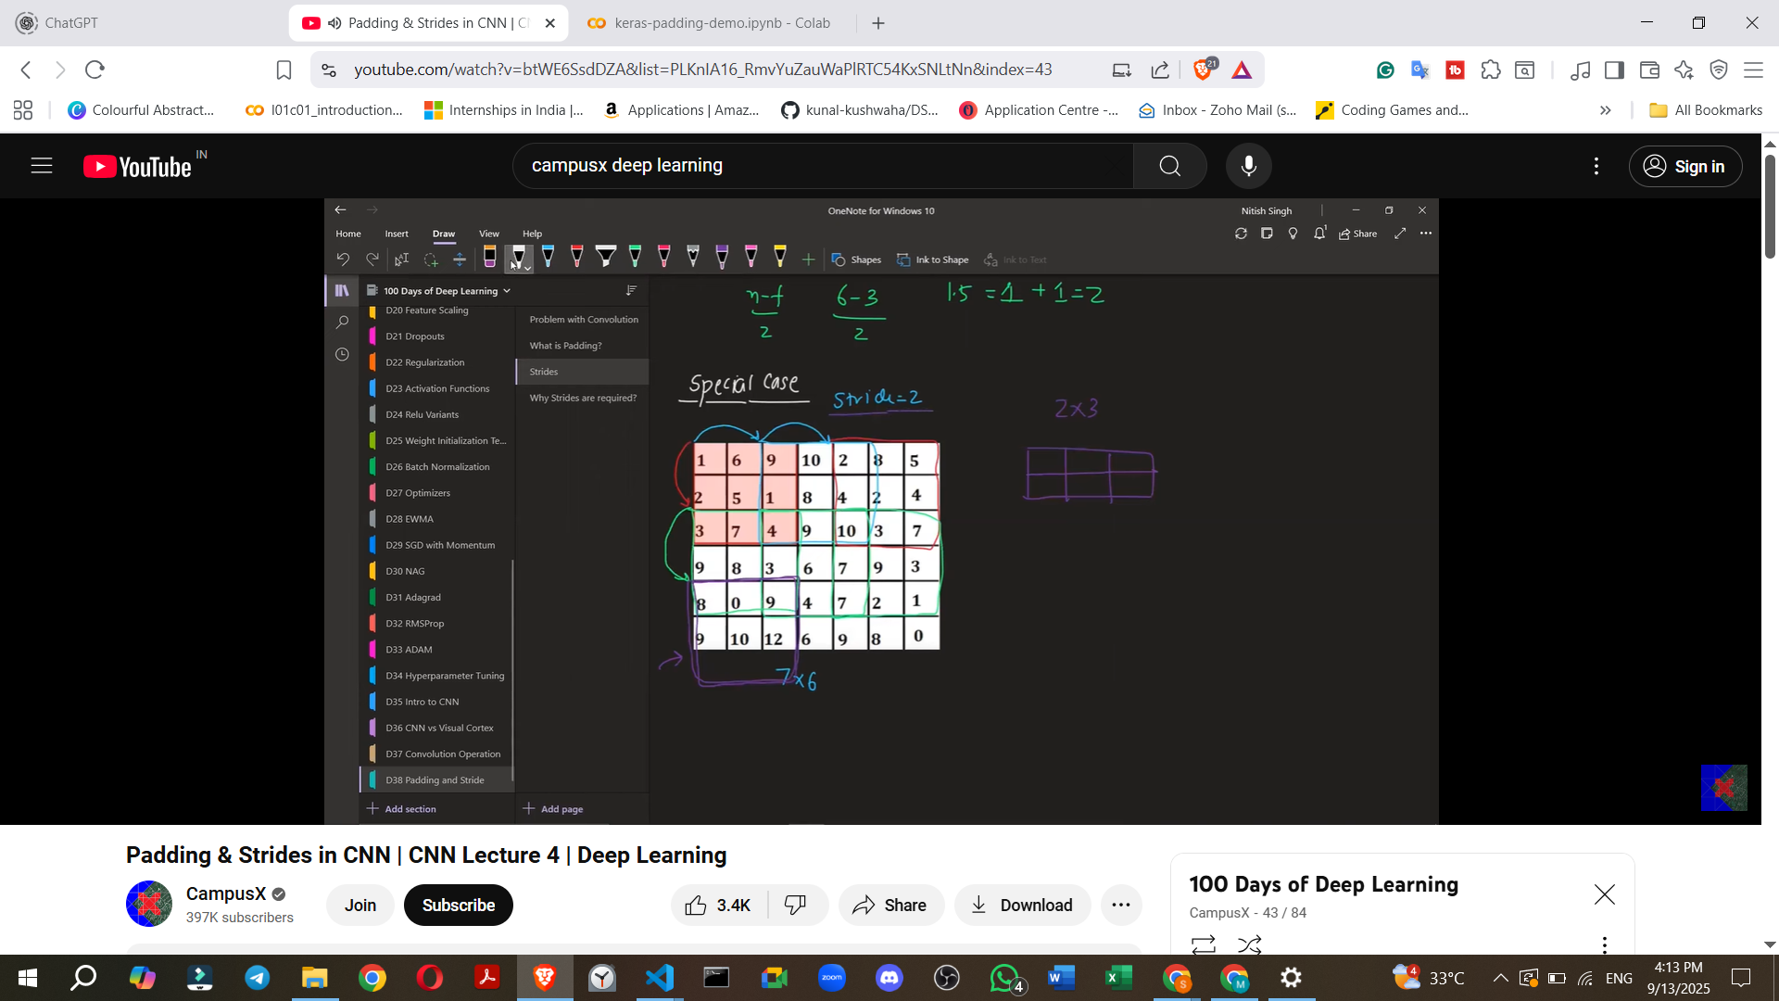
- Example: For a 6x7 image (N_rows=6, N_cols=7), a 3x3 filter (F=3), and a stride of 2 (S=2):
  - For Rows: (6 - 3) / 2 + 1 = 3 / 2 + 1 = 1.5 + 1 = 2.5. Applying floor: 1 + 1 = 2 rows.
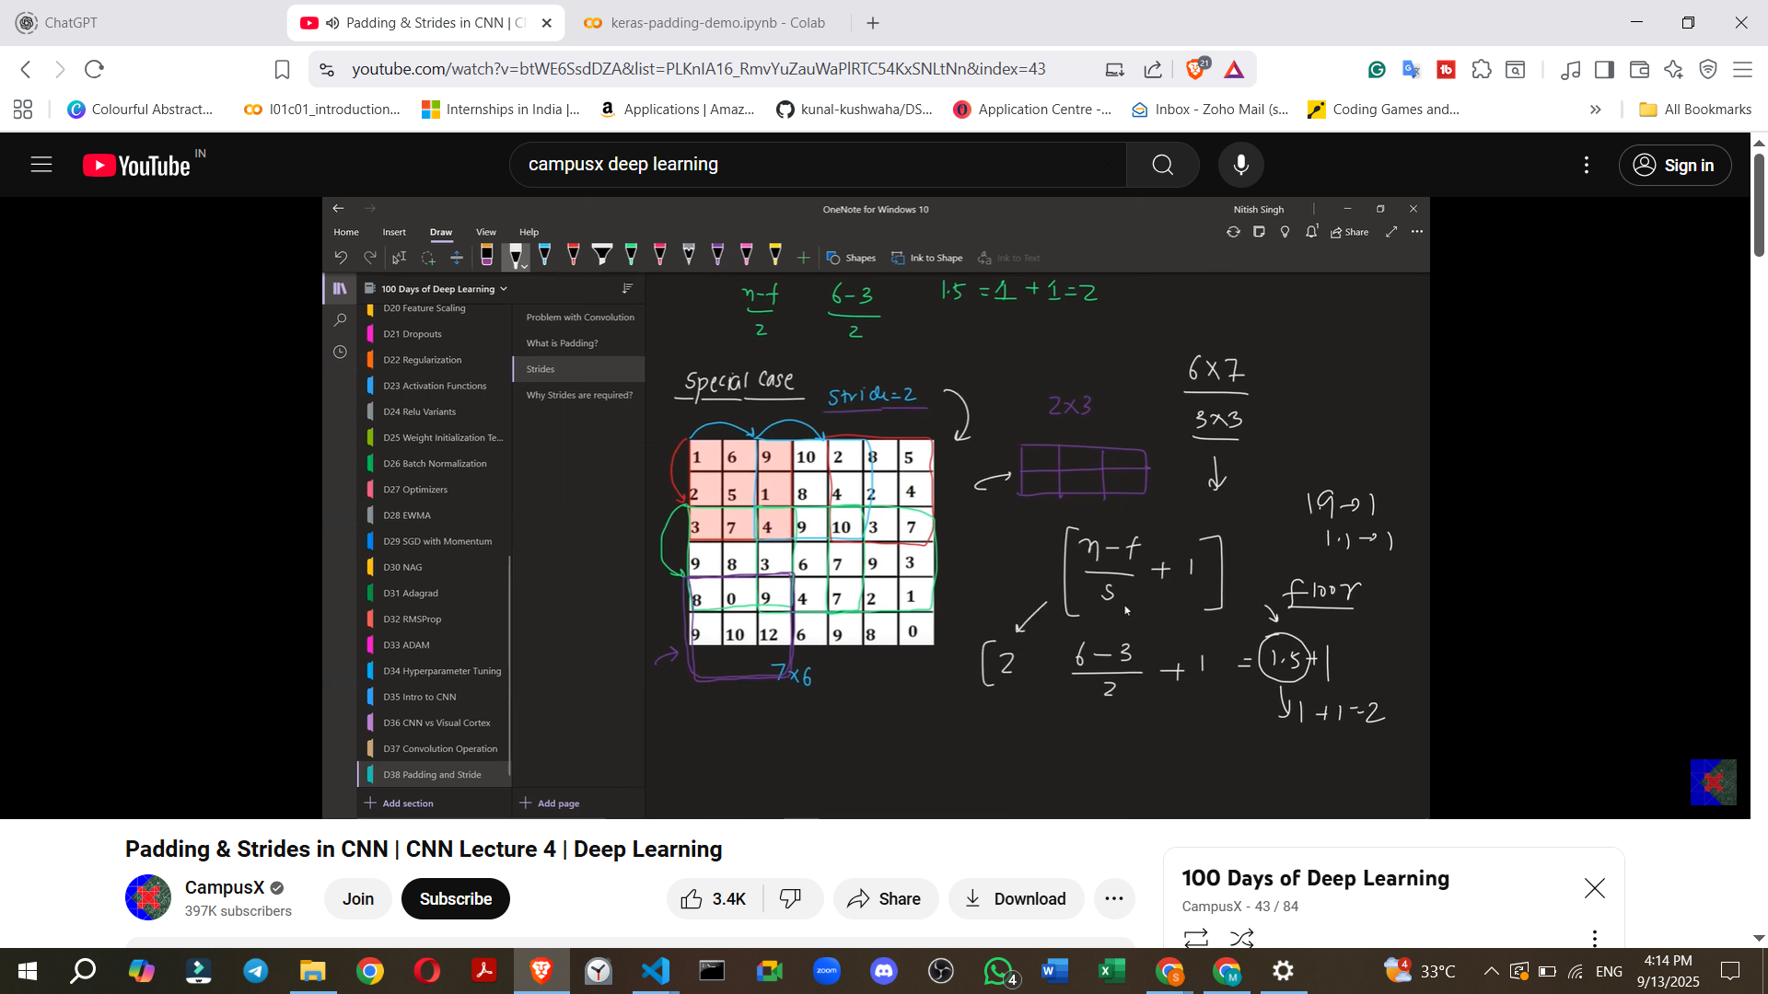
  - For Columns: (7 - 3) / 2 + 1 = 4 / 2 + 1 = 2 + 1 = 3 columns.
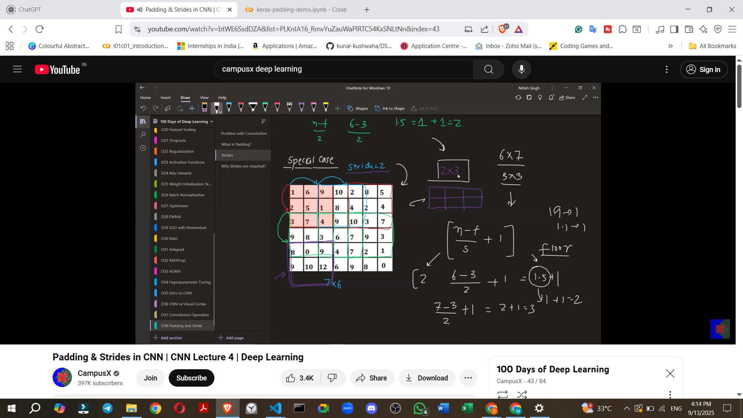
  - The resulting feature map would be 2x3.
9. Need for Strides (Why use Stride > 1?)
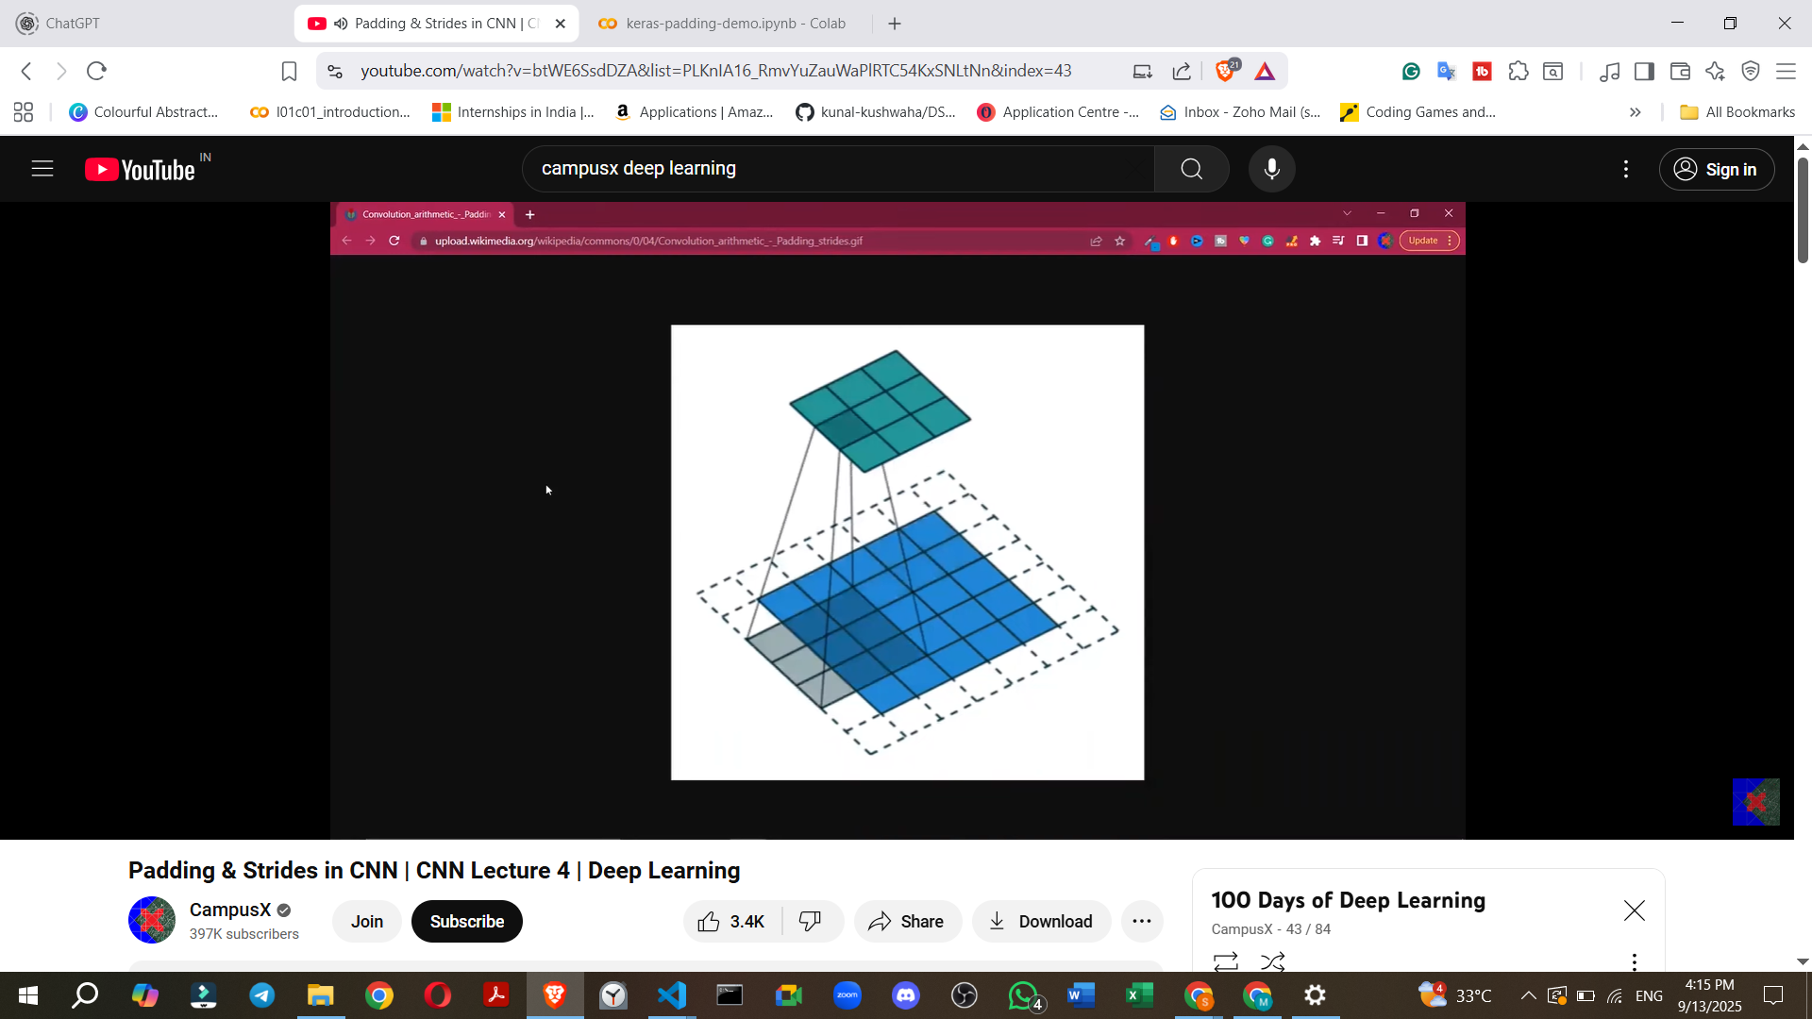
- Using a stride greater than one is sometimes called "strided convolution".
- There are two primary reasons for using strided convolution:
  - 1. Focusing on High-Level Features:
    - A small stride (e.g., 1) captures fine details or "low-level features" in an image.
    - A larger stride causes the CNN to "jump through" information, essentially skipping many pixels.
    - This results in the CNN capturing only "high-level" or "coarse" features, which might be sufficient or desired for certain computer vision problems.
  - 2. Reducing Computational Power/Speeding up Training:
    - A larger stride means fewer convolution operations are performed.
    - This can significantly speed up the training process, especially for very large datasets.
    - Note: This reason has become less critical in recent years due to increased computing power, so many models now often use a default stride of 1. However, strides are still relevant for specific problems.
10. Implementing Strides in Keras
keras-padding-demo.ipynb
keras-padding-demo.ipynb
- In Keras, strides are implemented using the strides parameter in the Conv2D layer.
- The strides parameter takes a tuple (e.g., (2, 2)) where the first value is the stride for horizontal movement and the second for vertical movement.
  - For example, strides=(2, 2) means the filter moves 2 pixels horizontally and 2 pixels vertically.
  - It's possible to use different stride values for horizontal and vertical directions (e.g., strides=(2, 1)).
- Keras Demo for Strides:
  - A model with an input of 28x28 and three convolutional layers, each with strides=(2, 2) (and implicitly padding='valid' since it's not specified as 'same'), shows a rapid reduction in image size.
  - After the first layer, the image reduces to 13x13 (calculated as (28 - 3) / 2 + 1 = 12.5 + 1 = 13.5, floored to 13).
  - It then reduces to 7x7 and further to 4x4 after subsequent layers, demonstrating significant information loss (reduction in resolution).
11. Future Topics
- The next video will cover Pooling operations.
- Following that, a complete CNN architecture will be built.

